Team Motorola Mobility

TVEye Finance Application
Design Document

Languages

The languages used in this project are Java and XML. Java will be used to form the backbone of the application, because the application is being written for the Android platform. XML will be used to make designing layouts for Android easier. To generate the dynamic layout for the Grid pages, Java will be used to generate the XML.

Frameworks/Libraries/APIs

The standard Java libraries for programming in Android will be used. We were also provided with a four proprietary APIs by our contacts at Motorola Mobility that will be used to contact the back-end of the application. These APIs are User Registration, News Retrieval, Bookmark Management, and Portfolio Management. In order to interface with their server, the HttpClient library by Apache will be used.

Code Repository Organization

Our code repository organization matches the organization of the project in Eclipse. We chose to do this as it is all one application.

Database

As the project is to implement the client and the server was already put into place by Chao at Motorola, there is no need for a database to store information.

System Organization/Architecture

The overall organization of the system, shown in Figure 1 below, was established by Chao at Motorola Mobility when designing the API for the server. The client that is being developed for the project will use the APIs mentioned above to retrieve information from the server and send client data back to the server.

The client has its own organization. It centers around a main page that will display the top news articles. Users can then drill down to a specific story from this page. If they choose, from the story they can move to a group of stories about a specific company. From any of these screens they can access the main settings page. This page will link to the various other settings pages and back to the previous and main screens.

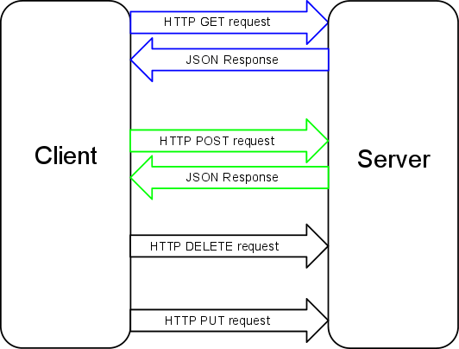
Figure 1. Illustration of client server communication setup per API provided by Motorola Mobility.

Rationale for approach

The client-server interaction was not designed by us, nor for the most part was the client layout. However, one change we made to the client was the flow from the main page. Originally, the program was designed to flow from the main page to a company page, and from there to a story page. We changed this flow because it was not efficient for the general user who intends to read the articles presented to them by the application. The revised overall navigation flow throughout the application can be seen on the following pages in Figures 2 and 3. Our suggested change was strongly supported during the design critique, and approved by Chao and Jehan.

Communication Protocols

A REST (REpresentational State Transfer) style API will be used to communicate with the server. This API is based on the HTTP 1.1 protocol. The server will respond to the client in JSON format.

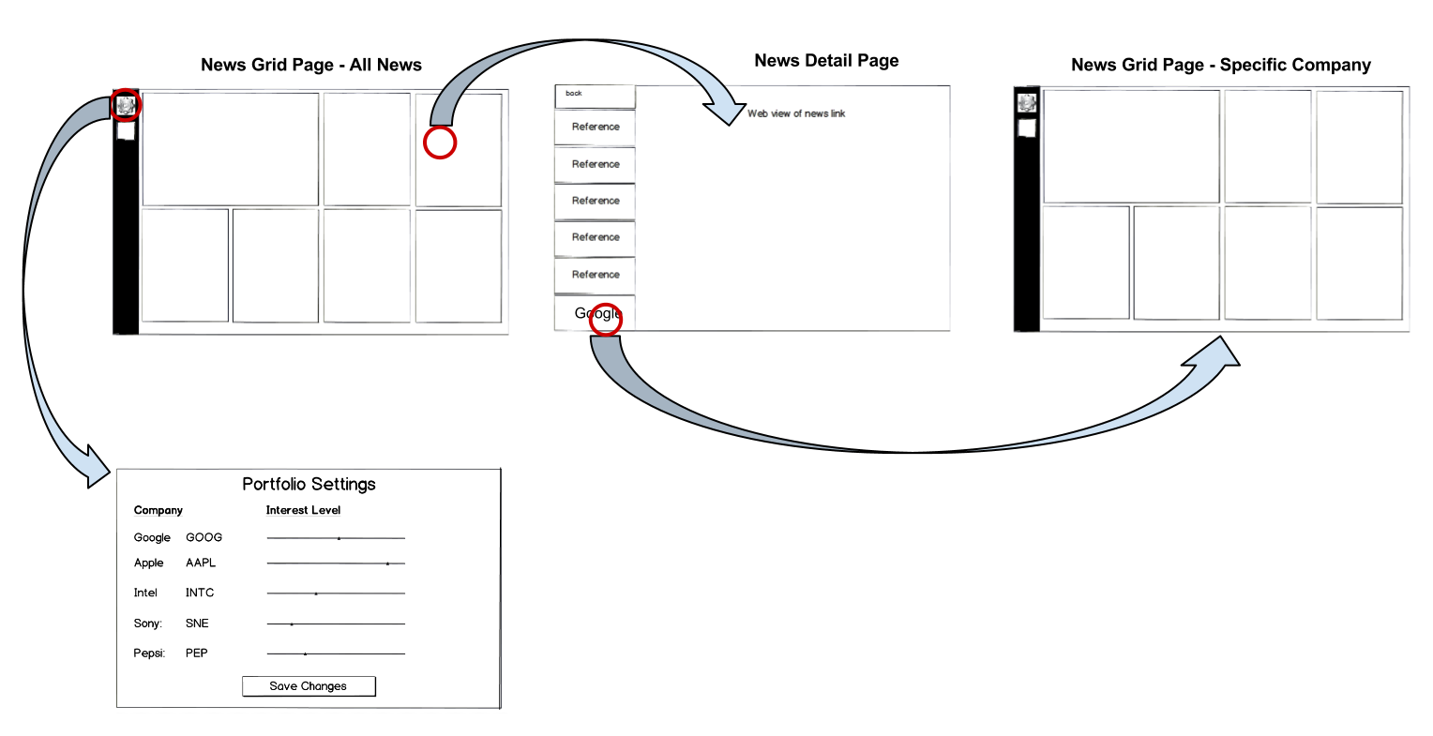

Figure 2. Navigation flow through application.

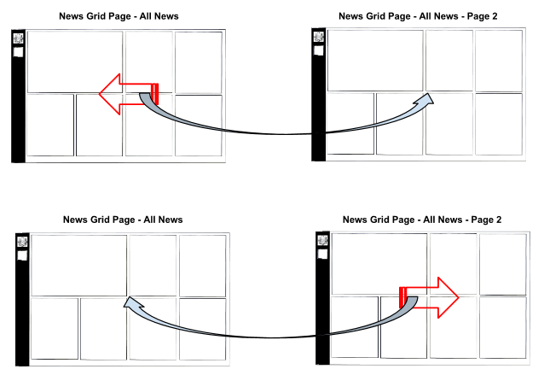

Figure 3. Navigation for Grid News Page.

Testing

Testing of the application will involve three different types of testing. First, unit testing will be completed by the programmers as they finish different steps in the development. System testing once the entire application is completed will also be done to ensure that all of the requirements have been met and that the client functions as it is should. Finally, if approved by Motorola Mobility, usability testing will be completed with outside users to ensure that the design is easy and natural for others to use.

Development Environment

The application will be developed using Eclipse with the Android SDK plug-ins. In addition, an emulator with a XOOM skin will be used until a physical XOOM is received from Motorola for testing.

Division of Labor

The Activites will be split up among the team members, and each member will be responsible for meeting the guidelines for layout, functionality, and unit testing for their pages. Greg is in charge of the News Grid Pages. Erin is responsible for the Registration Page. Nate is going to work on the Login and News Detail Page. Cory is in charge of the Settings Page. The team will work together during the integration, system testing, and usability testing phases, because these concern the entire system.

Design Methodologies

We have decided to use an Agile development process. We will set weekly goals, and at the end of the week will examine each other’s progress and update the team members’ goals for the next week, while trying to stay on schedule with the overall plan (as seen below). The final product will be created by incrementally adding functionality, testing and updating.
Gantt Chart of Overall Plan

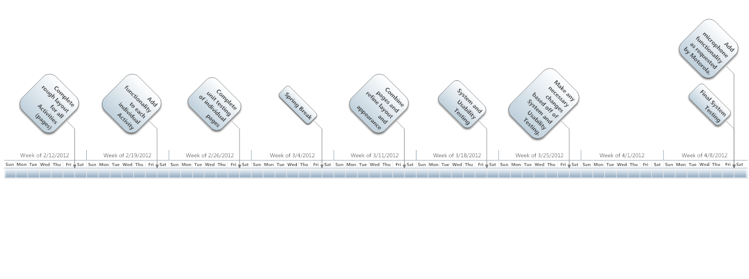
Table of Gantt Chart

Task | Assigned To | Start | End | Duration
Create TVEye Finance Application Client | Team Motorola Mobility | 2/10/2012 | 4/13/2012 | 64
Complete rough layout for all Activities (pages) | Each team member is assigned different Activities (pages) | 2/10/2012 | 2/17/2012 | 8
Add functionality to each individual Activity | Each team member is assigned their Activities (pages) | 2/17/2012 | 2/24/2012 | 8
Complete Unit Testing of individual pages | Each team member is assigned their Activities (pages) | 2/24/2012 | 3/2/2012 | 8
Spring Break |  | 3/2/2012 | 3/9/2012 | 8
Combine pages and refine layout and appearance | Complete as a team. | 3/9/2012 | 3/16/2012 | 8
System and Usability Testing | Complete as a team. | 3/16/2012 | 3/23/2012 | 8
Make any necessary changes based off of System and Usability Testing. | Complete as a team. | 3/23/2012 | 3/30/2012 | 8
Add microphone functionality as requested by Motorola. | Complete as a team. | 3/30/2012 | 4/13/2012 | 15
Final System Testing | Complete as a team. | 4/6/2012 | 4/13/2012 | 8

